If any aws service wants to access some other services of aws, then by default that service doesn’t have permission to access, so to provide permission to consumer service we need to create role and assign to consumer service.

In role we need to give permission to service which other service want to consume.

Steps to assign role to ec2 instance:

1. Create role.
2. Select ec2 instance for which you want to assign role.
3. Then click on action and then select security then select modify IAM role.

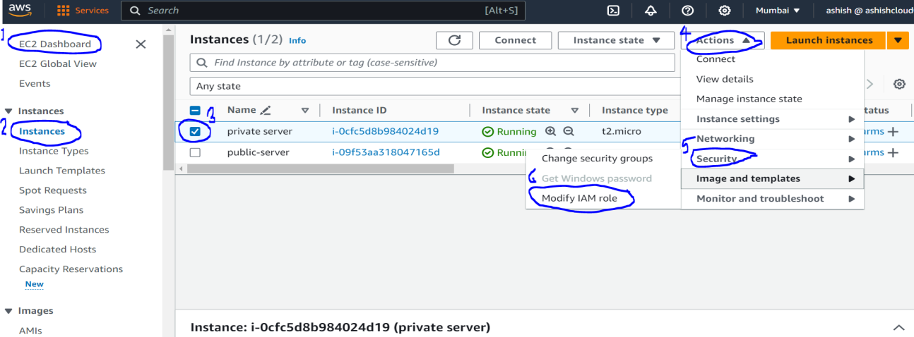

1. Then In IAM role, search your role which you want to attached to instance.

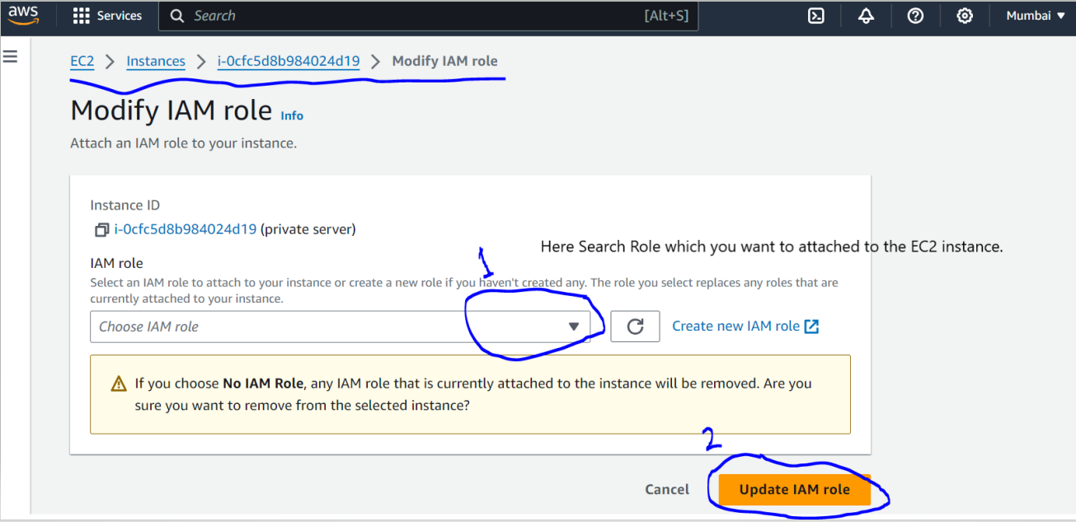

1. Then click on Update IAM role